Conference and Meetings Booking Form

Please complete the below form to confirm your booking here at Stoke on Trent College. Once submitted you will be contacted by a representative of the Conferences and Events Office with written confirmation.

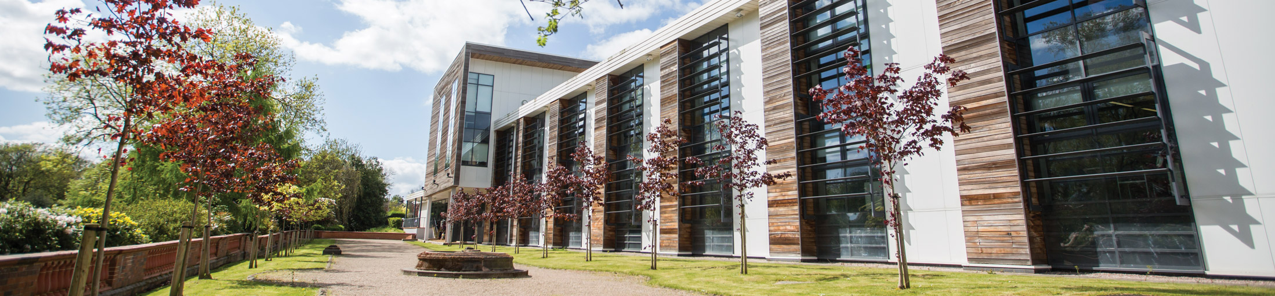

Client Details

Company Name
Organisers Name
Contact Name
In attendance on the day if different from above
Event Taking Place
Billing Address
Telephone Number
Email Address
Name of Event
Is there any known or Likely media interest in the prosed event

General Details

Arrival Date
Arrival Time
Departure Time
Number of Delegates

Room Requirements

Equipment Requirements (please complete if appropriate)

Computer Access guest login
Flipchart
TV and Smart Screen
Wireless Internet

Catering Requirements (please complete if appropriate)

 | Quantity | Time
Registration Tea & Coffee & Danish
Morning Tea & Coffee
Classic Package
Premium Package
Corporate Package
2 Course Sit Down Lunch
Afternoon Tea & Coffee
Please attach a copy of your program details if available

Additional Information

Car Parking Yes No

If yes, how many cars do you expect to enter college?

Signage from Pedestrian Entrance/ Car Park Yes No

If yes, signage to read:

Please send a company logo if required

Other Information

Have you had any contact with a member of the Conferences and Events Office prior to completing this form? Please indicate:

Susan Macmillan | Yes | No
Dawn Vincent | Yes | No

Please note:
Final Numbers must be confirmed in writing three working days prior to the date of the function.

By completing this form you are now subject to the Terms and Conditions of Stoke on Trent College
Conferences and Events Office.

Signed
Name
Date

Room No | Room | Horseshoe Style | Cafe Style | Boardroom Style | Theatre Style
AEB | A-Block Executive Boardroom | 18 | NA | 20 | 20
 | A – Block Lecture Theatre | NA | NA | NA | 90
LF02 | LF02 Steelite Conference Room | 20 | 16 | 22 | 30
LS01 | LS01 Lifestyle Boardroom 1 | 18 | 24 | 20 | 40
LS02 | LS02 Lifestyle Boardroom 2 | 18 | 24 | 20 | 40
LS01 & LS02 | Boardrooms opened out. | 36 | 48 | 40 | 90

