Policy Aims

1.1 Stoke-on-Trent College aims to create an environment which fosters good relationships and encourages effective learning.

Policy Statements

2.1 Appropriate behaviour is a key attribute of employability and will be encouraged and developed within the tutorial system lined to skills, knowledge and behaviours from the intent of the curriculum.

2.2 Students will be encouraged to take responsibility for their own behaviour in and out of class

2.3 College community expected behaviours we will always promote:
i Good attendance – aim for 100%
ii Be prepared to learn and grow
iii Aim to be your best version of you
iv Working together, achieving together
v Respecting yourself and others
vi Never giving up; we are here to help
vii Take part in College community events and activities

Behaviours that have no place in our College community that we will always challenge:
i Bullying, cyberbullying and harassment
ii Disrespect for other people
iii Swearing and use of offensive language
iv Disrespect for our campus
v People without visible ID
vi Smoking in non-smoking areas

2.4 All full-time students will be made aware of what constitutes acceptable behaviour through signing The Deal (FE) or The Student Contract (HE) as part of induction. All part time students will be made aware of what constitutes acceptable behaviour through induction.

2.5 The College will promote good behaviour through praise, acknowledgement and effective teaching and learning strategies. The College will organise staff development and training on positive behavioural management.

2.6 Negative student behaviour will additionally be supported through the work of the Personal Tutors/Progress Coaches, College Mentor team and/or Behaviour Support Officers where appropriate.

2.7 Where appropriate a specific behaviour management agreement will be put in place, which will set out acceptable standards to be met by the student concerned; such agreements will be discussed, agreed and signed by the student.

2.8 Where behaviour remains poor and sanctions are to be used, the Learner Disciplinary Procedure will be followed.

2.9 Stoke-on-Trent College is committed to creating an environment that is welcoming and inclusive and where everyone is treated fairly and with dignity and respect. The College is a place where everyone will have the opportunity to fulfil their potential regardless of age, disability, gender reassignment and being a transsexual person, pregnancy or maternity, being married or in a civil partnership, race, religion or belief, sex, sexual orientation and socioeconomic status.

Responsibility for the Behaviour Management Policy

3.1 Executive Director of Student Experience is responsible for the development and implementation of this policy.

Monitoring

4.1 The Interim Vice Principal and/or Deputy Principal will monitor all sections of this policy. Regular reports and recommendations on all aspects of the Policy will be provided to the Executive team, and Governing body as appropriate. This Policy will be reviewed on an annual basis.

Approval

Approved by the College Executive team

Signed:

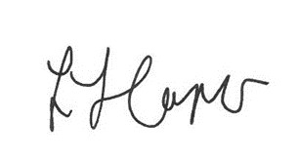
Principal & CEO

Endorsed by the College Corporation

Signed:
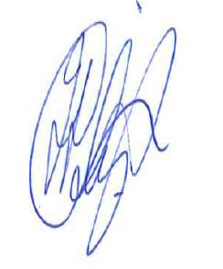
Chair

